**SÖDERHAMN Sectional**

**Product details $1800**

SÖDERHAMN seating series allows you to sit deeply, low and softly with the loose back cushions for extra support. You sit in comfort with a slight, pleasant resilience thanks to the elastic weave in the bottom and high resilience foam in the seat cushions.

**Materials & care**

* **Frame, 3-seat section**
* **Frame:** Plywood, Fiberboard, felt liner, Steel, Solid wood
* **Back cushion:** Polyester hollow fibers, Non-woven polypropylene
* **Upholstery material:** Highly resilient polyurethane foam (cold foam) 35 kg/co., Polyurethane foam 20 kg/co., Polyester hollow fiber wadding, Non-woven polypropylene
* **Laminated wadding:** Polyester hollow fiber wadding, Non-woven polypropylene
* **Bed slat holder:** Polypropylene plastic
* **Bed slats:** Layer-glued wood veneer, Birch veneer
* **Hook and loop fastener:**100% nylon
* **Total composition:**100% polyester
* **Cover for 3-seat section/ corner section cover**
* **Fabric:**3% nylon, 97 % polyester (100% recycled)
* **Back fabric:**100% polypropylene
* **Armrest cover**

3% nylon, 97 % polyester (100% recycled)

* **Frame armrest**
* **Frame:** Fiberboard, Solid wood
* **Upholstery material:** Polyurethane foam 20 kg/co.
* **Hook and loop fastener:**100% nylon
* **Laminated wadding:** Non-woven polypropylene, Polyester hollow fiber wadding
* **Corner section frame**
* **Frame:** Plywood, Fiberboard, Non-woven polypropylene, Steel, Solid wood
* **Back cushion:** Polyester hollow fibers, Non-woven polypropylene
* **Upholstery material:** Highly resilient polyurethane foam (cold foam) 35 kg/co., Polyurethane foam 20 kg/co., Polyester hollow fiber wadding, Non-woven polypropylene
* **Laminated wadding:** Polyester hollow fiber wadding, Non-woven polypropylene
* **Hook and loop fastener:**100% nylon
* **Total composition:**100% polyester
* **Removable cover Three-seat section cover/armrest cover/corner section cover** Machine wash, max 30°C, normal process. To be washed separately. Do not bleach. Do not tumble dry. Iron, max 110°C.Iron on reverse. Professional dry cleaning in tetrachloroethene and hydrocarbons, normal process.
* **Product size**
* **Height including back cushions:**
* 83 cm (32 5/8 ")
* **Height backrest:**
* 69 cm (27 1/8 ")
* **Depth:**
* 99 cm (39 ")
* **Width right:**
* 291 cm (114 5/8 ")
* **Width left:**
* 291 cm (114 5/8 ")
* **Free height under furniture:**
* 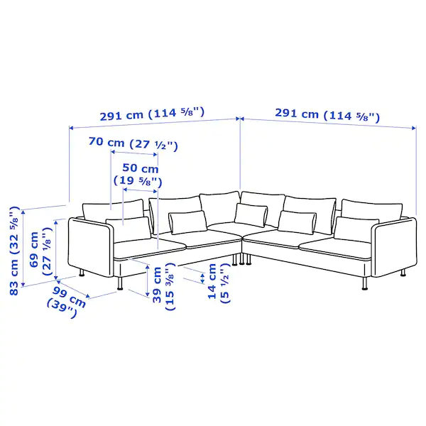14 cm (5 1/2 ")
* **Seat depth:**
* 70 cm (27 1/2 ")
* **Seat height:**
* 39 cm (15 3/8 ")